Source Code Management

**Course Code: CSE 2015 Slot: L14 L15**



**Name: Sharon Melhi**

**SEN No.: A866132524004**

**Faculty: Dr Monit Kapoor**

**Lab Session 1: Git Fundamentals**

**Computer**

A **computer** is any device capable of performing calculations, whether they are logical or mathematical.

**Program/Code**

A **program** (or **code**) is a set of instructions, often organized as an algorithm, that directs a computer to perform a specific task.

**Need for Managing Source Code**

Modern applications, such as Spotify, consist of multiple programs working together on both the frontend and backend to deliver smooth user experience. Regular updates are essential for:

* **Fixing Bugs:** Quickly resolving errors that may occur.
* **Improving UI/UX:** Enhancing the user interface and overall experience.
* **Optimizing Performance:** Addressing and refining issues for better performance.

For programmers, effective management of source code is crucial because:

* It ensures that all files remain in context throughout the lifecycle of the program.
* It facilitates collaboration, allowing multiple developers to work together on a shared codebase.

**Tools for Source Code Management**

### Git:

A version control system that runs locally on your computer. Git helps track changes and manage versions of your project.

### GitHub:

A global, cloud-based platform that hosts Git repositories, enabling developers to share, collaborate, and contribute to projects from anywhere in the world.

**Version**

A **version** in version control represents a snapshot of your project at a specific moment in time. This snapshot allows you to review, revert, or compare changes made throughout the development process.

# Lab Practical 1

## Installing Git in Windows

Step 1: Visit section 1.5 of pro git document and navigate to Windows section

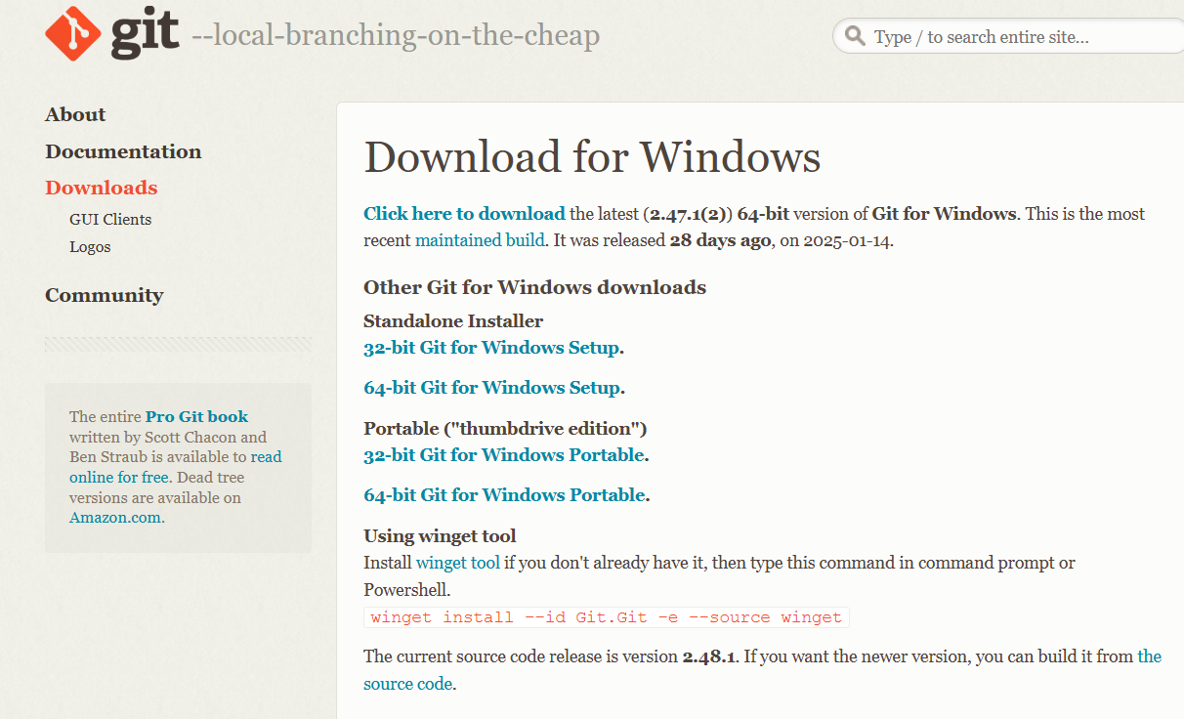

Step 2: Verify Git Installation:



# Basic CLI Commands

## 1) Command: pwd

**Description:** Prints the directory the user is working in.

## 2) Command: ls

**Description:** Lists all files and directories in the current directory.

## Command: date

Description: shows the current date and time in a standard format

## Command: clear

Description: The clear command in the CLI is used to clear all the current text and output displayed in the terminal window.



## Command: time

Description: The time command in the CLI is used to measure the execution time of a command or program.

## Command: cd ‘Directory’

**Description:** Changes the current working directory to the desired directory.

## Command: cd ..

Description: Goes back to the previous directory.

## Command: mkdir

**Description:** To create a new directory.

## 9. Command: rmdir

**Description: To delete a directory**

# 3. Vim Text Editor

## Command: vi hi.txt

**Description:** Opens (or creates) the file hi.txt in the Vim text editor.



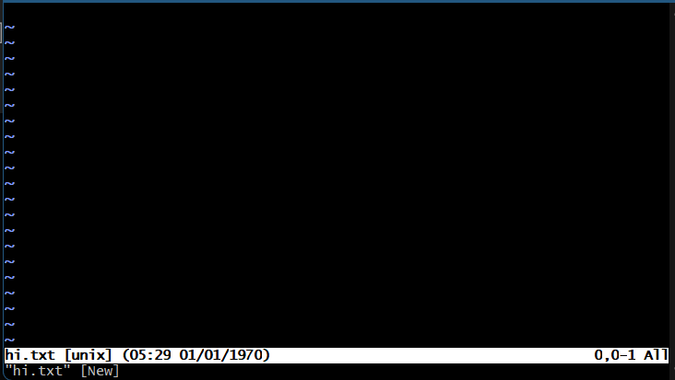

## Command: i (Insert Mode)

**Description:** Enters insert mode in Vim to allow text input.

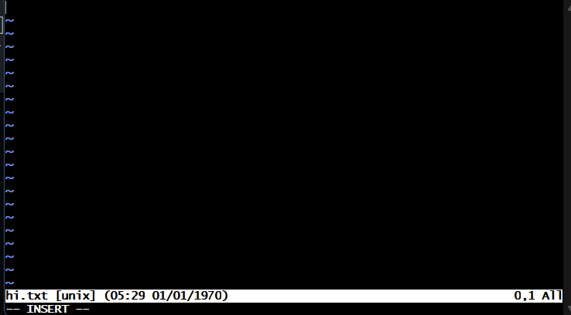

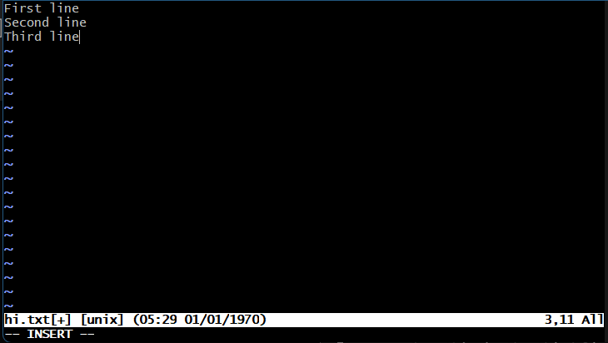

## Command: esc

Description: Used to exit insert mode

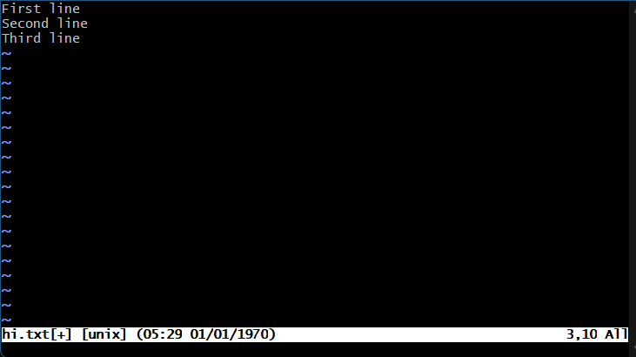

1. **Command: :wq**

**Description:** Saves the changes and exits the Vim editor.

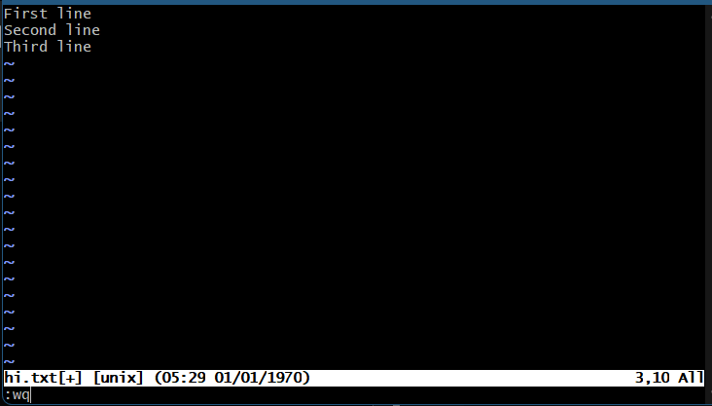

# 4. Git Commands

## Command: git - - version

Description: The git --version command is used to check the installed version of Git on your system.

1. **Command: git init**

**Description:** Initializes a new Git repository in the current directory.

1. **Command: git status**

**Description:** Displays the current status of the working directory and staging area.

**4. Command: git add Test.c**

**Description:** Add Test.c to the staging area in preparation for a commit.



**5. Command: git commit -m “add file one”**

**Description:** Commits the stage changes with the message “add file one”.

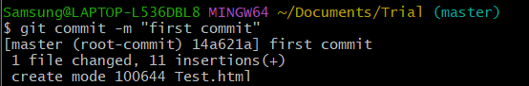

**6. Command: git log**

**Description:** Display the commit history of the repository.

**7. Command: git clone**

**Description:** To obtain a copy of an existing Git repository.

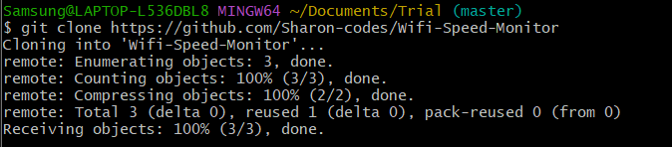

**8. Command: git log --oneline**

**Description:** For generating shorter commit ID.

SCM Project

The project was to make a repository in GitHub, make 3 branches and merge it with the main branch and access all 4 team-mate’s repositories, fork it, clone it, make some changes and merge them.

First, make your own repositories and make 3 branches and add files and merge with the main branch.

1. Go to the directory on your computer



1. Clone the GitHub repositories

1. Change to the folder



1. Now that you are in the main branch, make a new branch (html)



1. Create a file, add code and add the file

1. Commit the file as commit 1 in branch 1

1. Reopen the file, make changes and commit it as commit 2 in branch 1

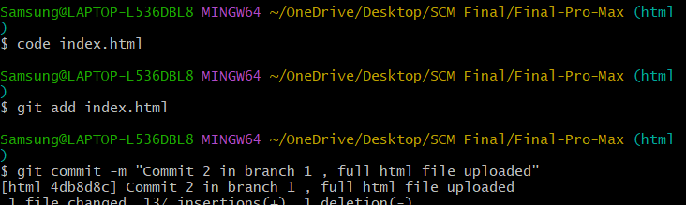

1. Push the html branch

1. Go back to the main branch

1. Make an initial commit as a README.md and commit it

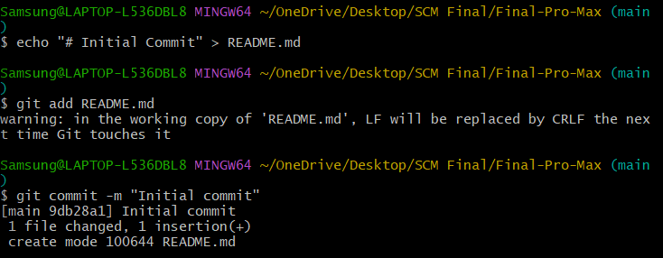

1. Push the main branch

1. Creating a new branch (CSS)



1. Create a file, add code and add the file, Commit the file

1. Reopen the file, make changes and commit it

1. Push the CSS branch

1. Go back to the main branch

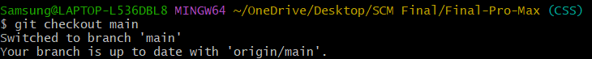

1. Create a new branch (readme)



1. Using echo, add some lines and commit it as Added README title

1. Using echo, add some more edits and commit it as Added Project Description

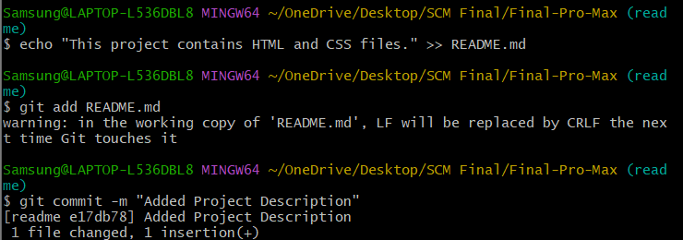

1. Push the readme branch

1. Go back to the main branch

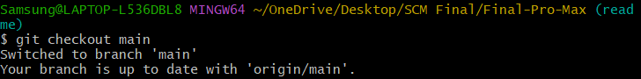

1. Merge html, CSS, readme branches

1. Push the main branch

Now we will clone the repository of all my Team Members, ADITYA, KHUSHI, ISHRIT and RITVIK

* Aditya

1. Go back to the folder where you want to save the folder



1. Fork the repository
2. Clone it

1. Change to the cloned repository folder



1. Git remote add

1. Open the file you want to edit and make some changes, add the file and commit it

1. Push the main branch

* Khushi

1. Go back to the folder where you want to save the folder



1. Fork the repository
2. Clone it

1. Change to the cloned repository folder



1. Git remote add

1. Open the file you want to edit and make some changes, add the file and commit it

1. Push the main branch

* Ritvik

1. Go back to the folder where you want to save the folder



1. Fork the repository
2. Clone it

1. Change to the cloned repository folder



1. Git remote add

1. Open the file you want to edit and make some changes, add the file and commit it

1. Push the main branch

* Ishrit

1. Go back to the folder where you want to save the folder



1. Fork the repository
2. Clone it

1. Change to the cloned repository folder



1. Git remote add

1. Open the file you want to edit and make some changes, add the file and commit it

1. Push the main branch

